**Demonstration and Screenshots of all the routes (MILESTONE #4)**

**Secure Application in Node.js**

Shutters by Travelgram

**Bharadwaj (801151165)**

**Milestone Tasks and Design:**

**Add Logic to Handle User Login**

* When the user clicks the sign in button this should send a request to verify that username and password submitted belong to an already registered user.
* If the user credentials do not validate, the login view should be displayed showing an error message. (e.g. Either username or password are incorrect. Please try again.)
* If the user credentials are verified display the profile view.
* **Note** that this might require updating your models and database to account for username and password.  Your choice on how and where to handle representing these properties in the models and the database (e.g., adding to existing models and documents or creating new models/documents specifically for login info)

Pseudocode:

* If the action parameter validates to a value of “signIn”:
  + Check the session for “theUser” attribute
  + If a “theUser” attribute is set dispatch to **profile** view (savedConnections.ejs).
  + If there is no valid User object stored in the session
    - Checks the http request for a parameter called “username”
    - If there is no username parameter, or it has an unknown value dispatch to the login view.
    - If there is a username parameter and is valid check the http request for a parameter called “password”
    - If there is no password parameter, or it has an unknown value dispatch to the login view.
    - If there is a valid username and password, verify the username and password matches a valid user in the database.
    - If the user credentials are valid retrieve the list of saved connections for that user from the database. If a user doesn't have any saved connections this should be empty.
    - Add the list of saved connections to the session object as “currentProfile”.
    - Dispatch to the **profile**view

**Applying Security Measures**

* Update your application to make use of the express-validator package to validate all input values read into the application (login and add connection)
* Update your application to escape dynamic output displayed in all views

**Index Page**

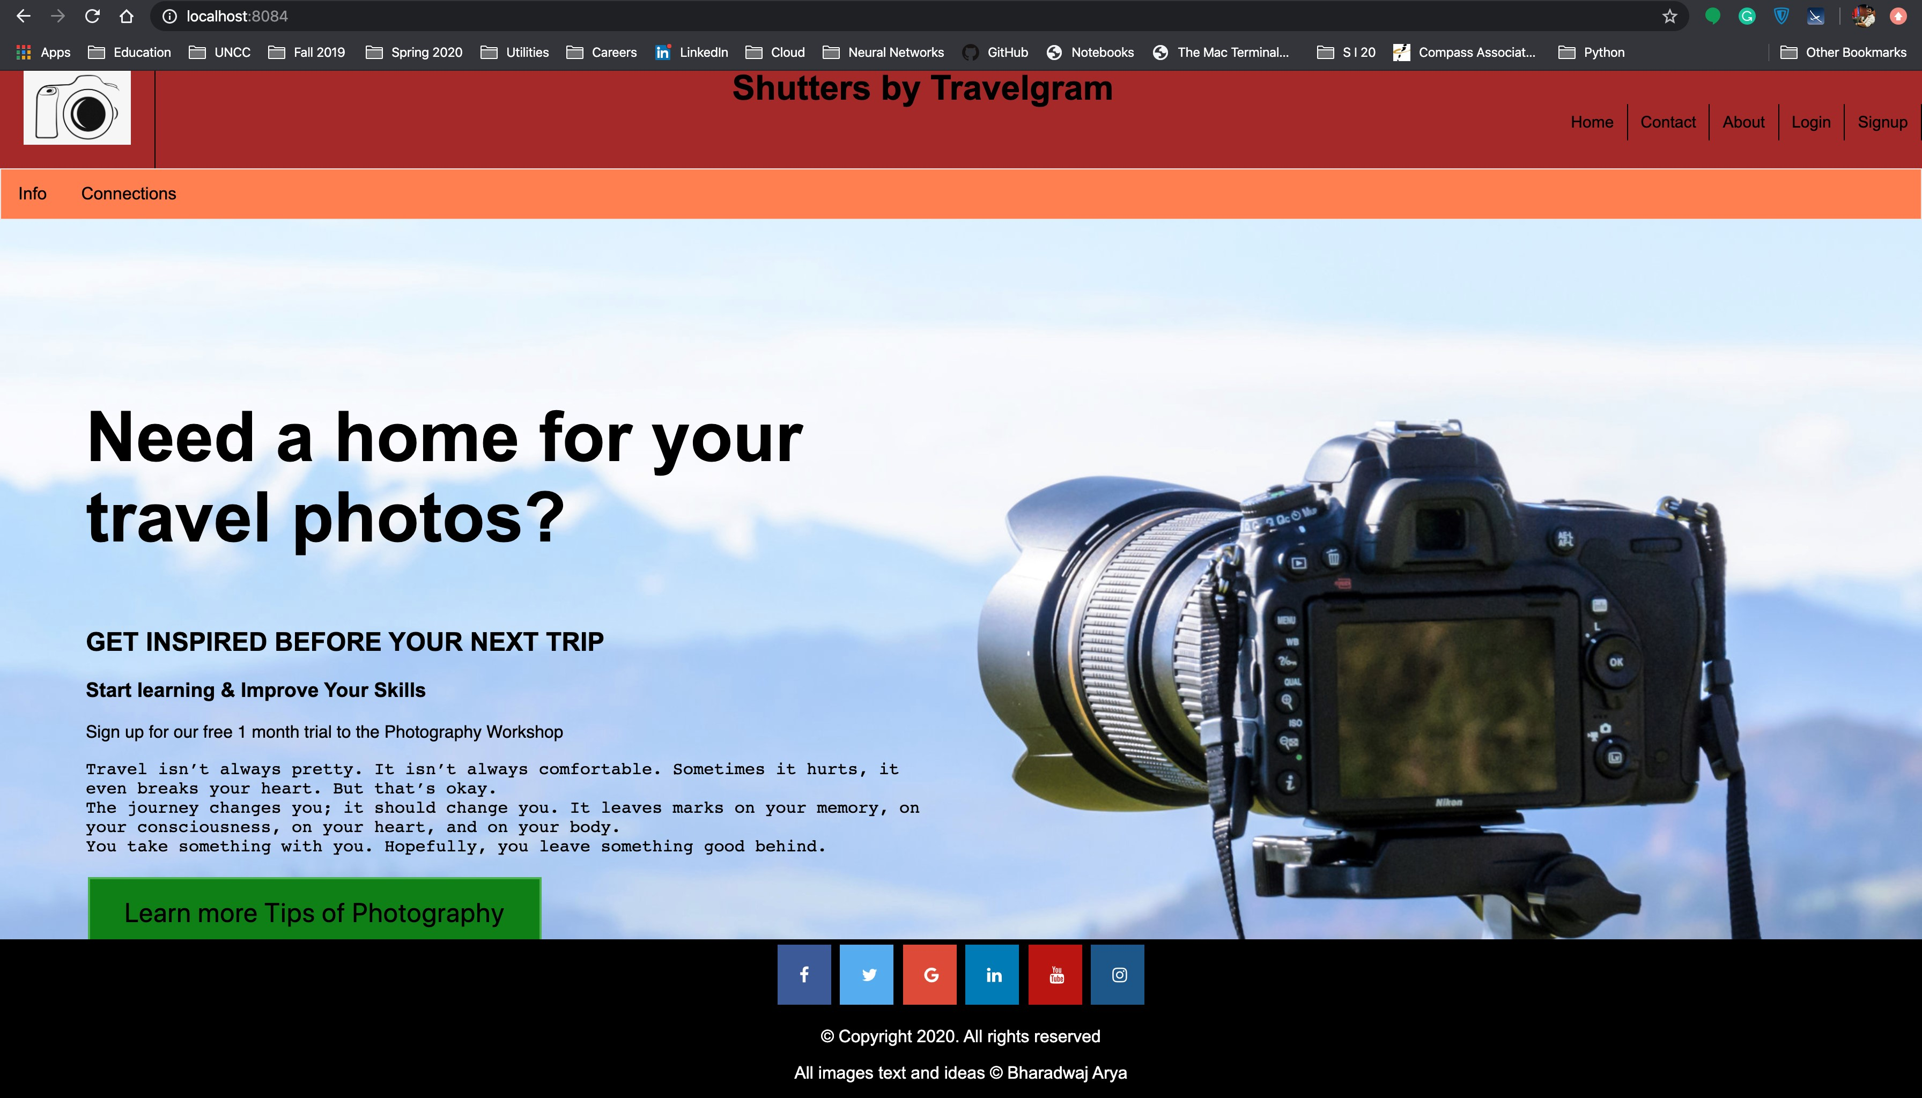

**Info.ejs**

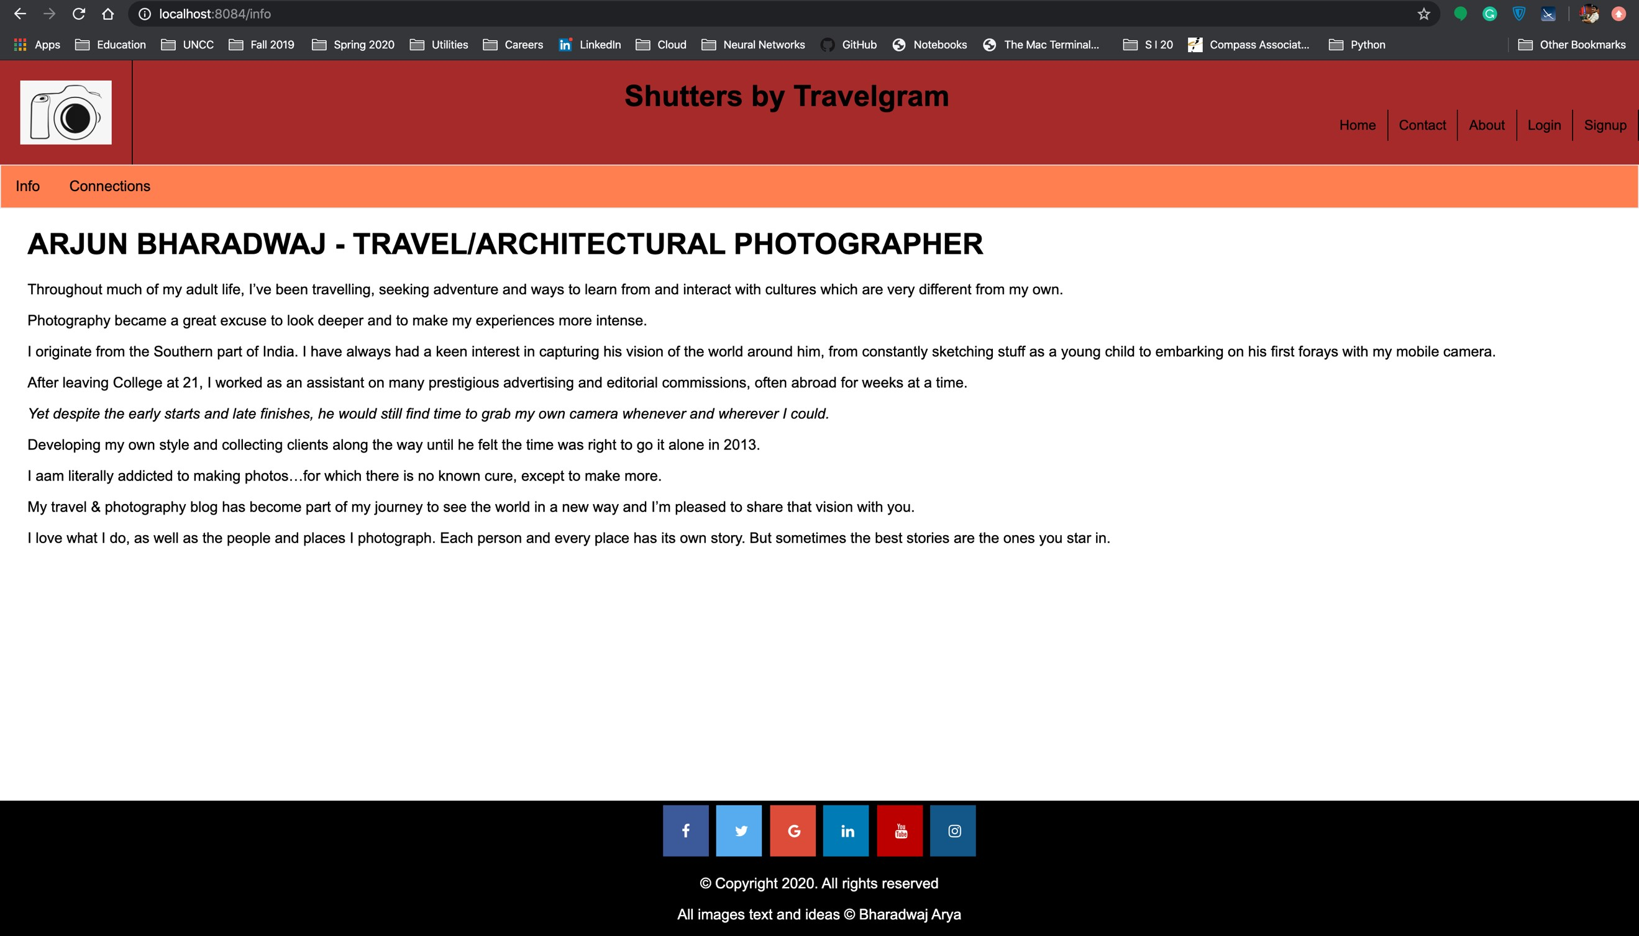

# Connections.ejs (list of all connections). This populates all the connections without the session being created. So, the username is not getting displayed as the session has not been created.

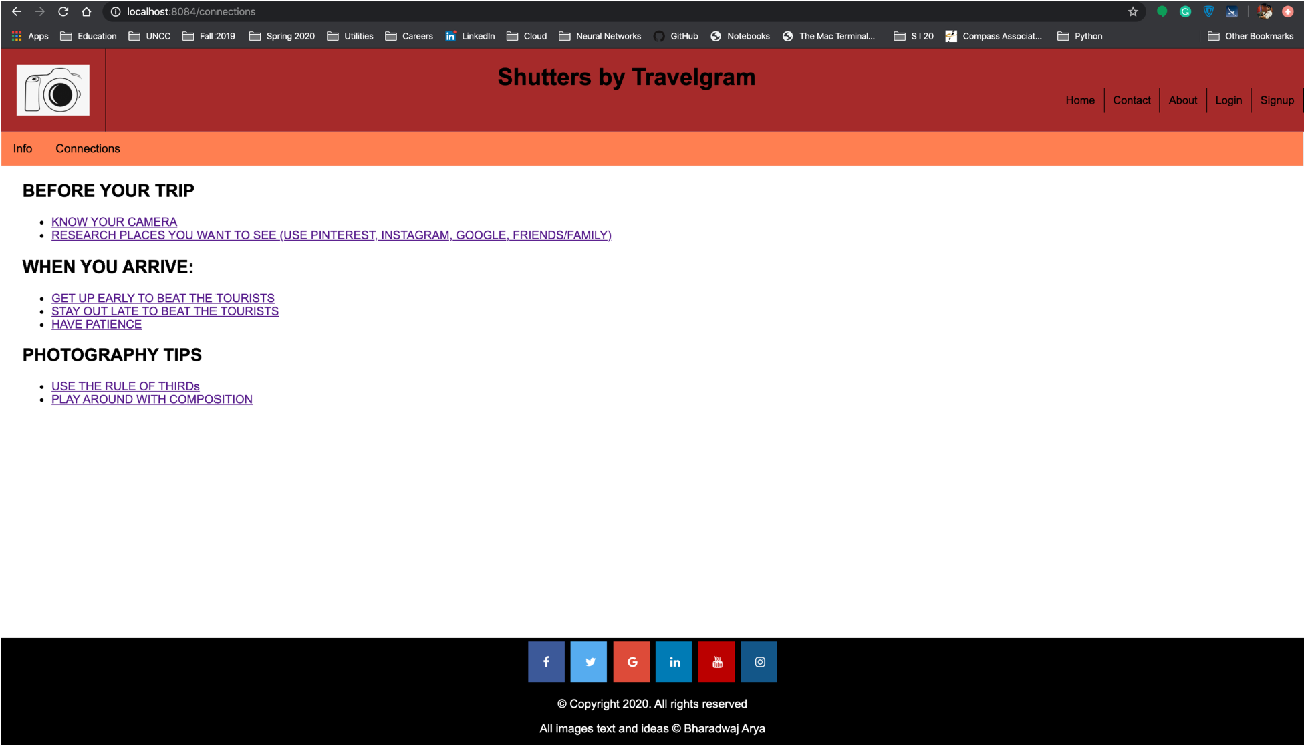

# Redirecting to home page by clicking the logo

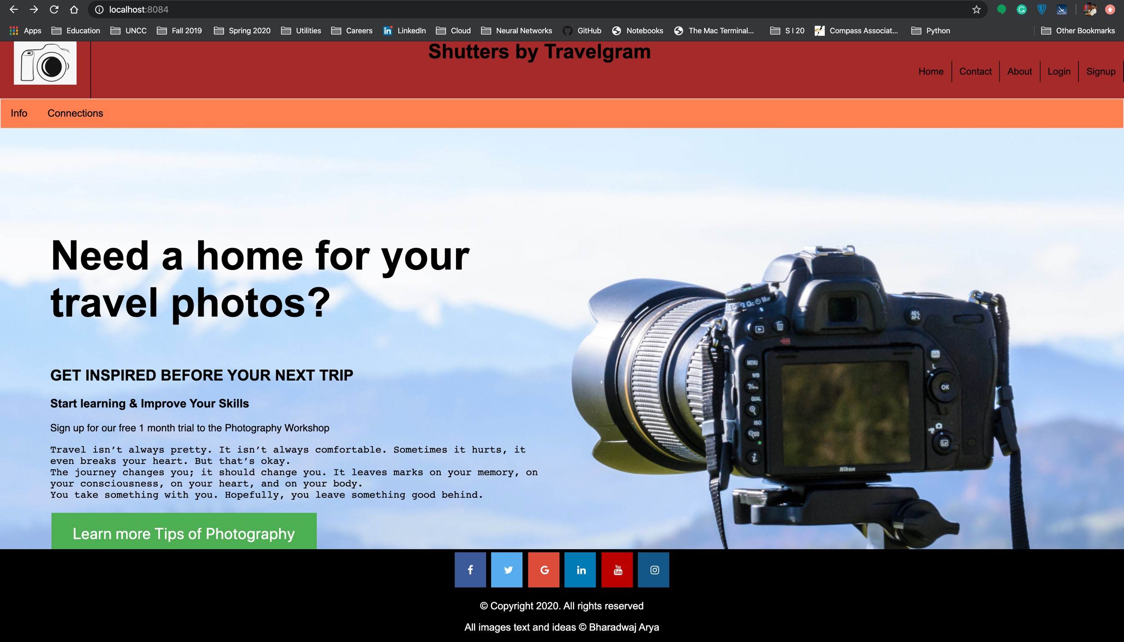

**Login Page for Login button which opens a form, so when we click the login button a session gets created for the hardcoded user. This is a mandatory action that has to be performed by the user for the session to get activated. The login functionality actually uses a middleware function to automatically route all the requests to create a session.**

**This is established through the session object. Once a user completes the login form, we are bypassing an actual login functionality here and assuming this is a new user and a session attribute is used to track this user.**

**The next step is to allow the user to add the connections :**

**When the login form is submitted for the first time initially, a user session gets created and initially there would be no connections for the logged in user. So, a message gets displayed for the user to select any connections from the list of available connections to which the RSVP action is done for.**

**The navigation bar also displays the user details (User’s first name and Last name) from the user ProfiledB that has been created.**

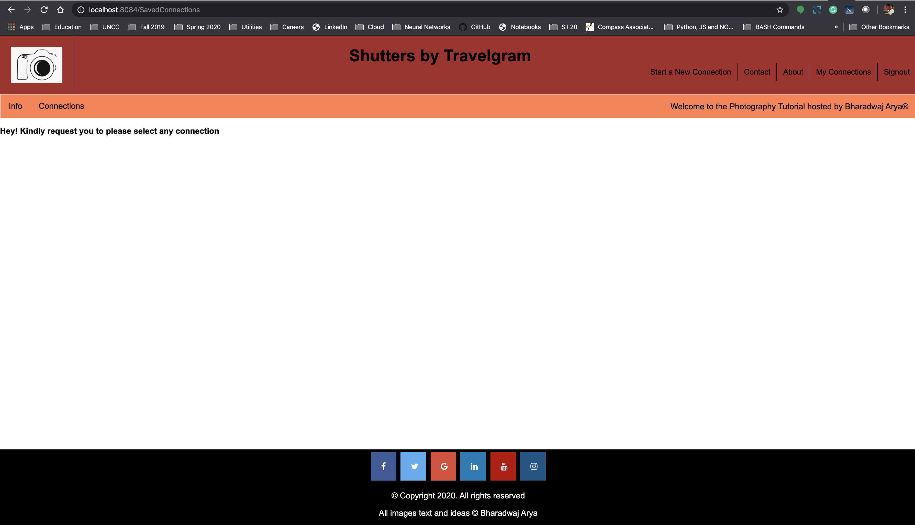

**This page details all the list of connections that has the user can see. Also, the session has been created and as a result of which the username is displayed in the connections page.**

**UserConnection – represents a connection object saved to the user profile ( associates a connection to a user profile) with the following properties:**

* **Connection**
* **rsvp**

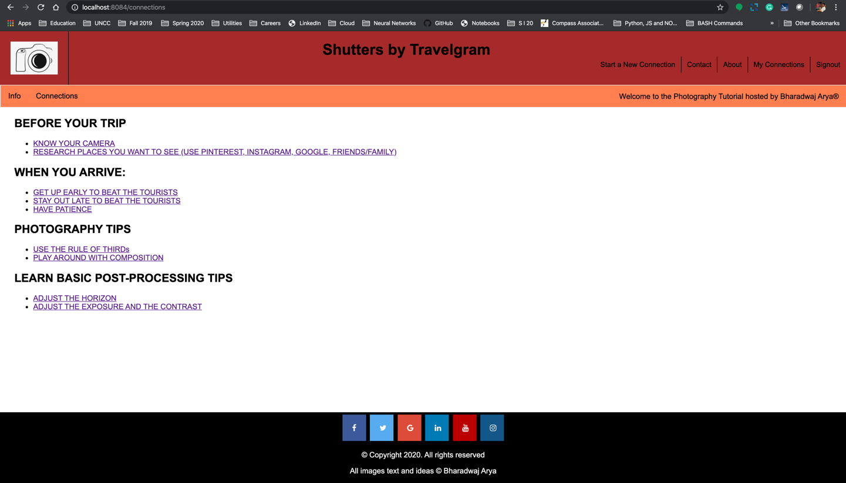

**Once the user selects a connection from the list of available connections, the details regarding the selected connection (based on conID) is fetched from the connectionDB. In this. Milestone, I created two separates sessions for handling the user**

* **A session where all the user details are stored. This session fetches the details of the user from the object created of the USER class which contains all the User details like User’s first name, last name, E-Mail ID etc.**
* **We create a session for the User profile from active user connections (any updates from Saved Connections).**

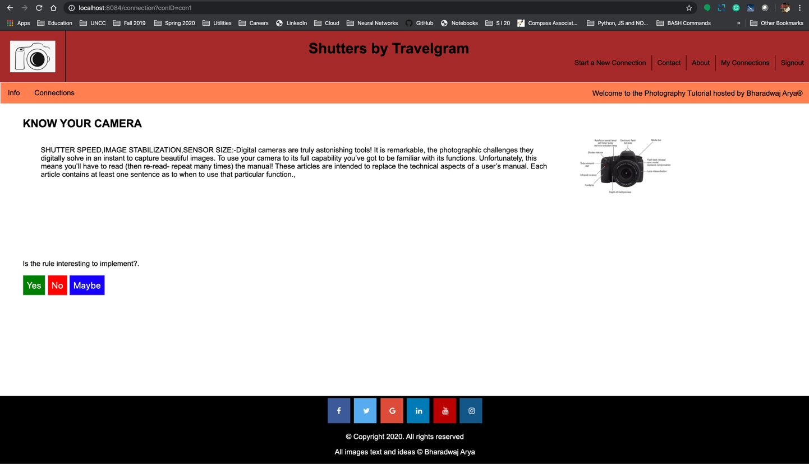

**When the user tries to add a connection (based on the RSVP action of the user), a session is created for the user that actually handles all the updates of the user from the Saved connections**

**The list of all updates made by the user are pushed into an empty array *userarraylist[ ] from the user_savedconn.***

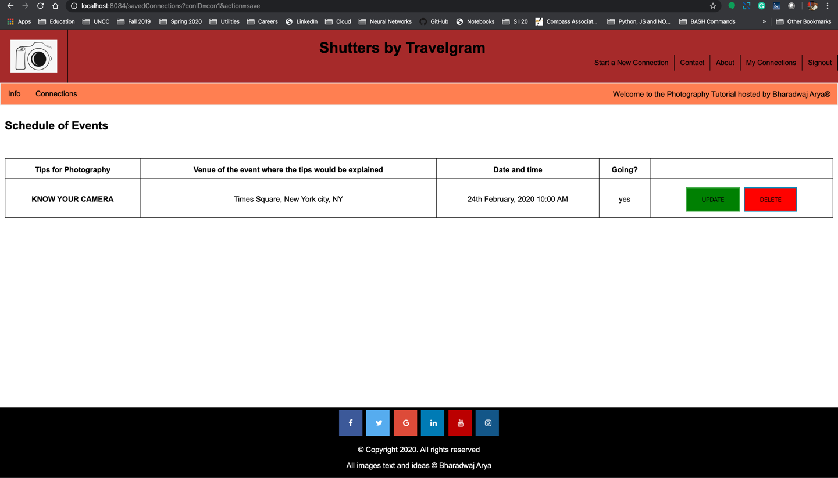

**Based on the action performed by the user (Save or delete) i.e an action SAVE performs an addConnection operation and action DELETE performs removeConnection. The user can add or remove any number of connections from the list of available connections and the RSVP action of the user is dynamically rendered on the savedConnections.**

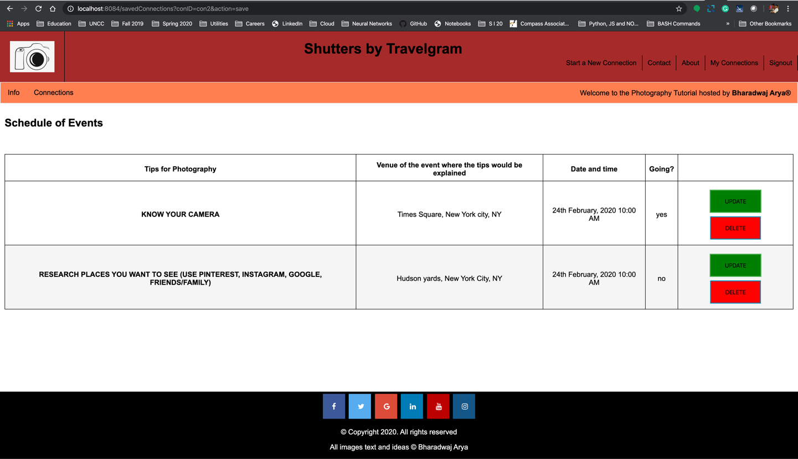

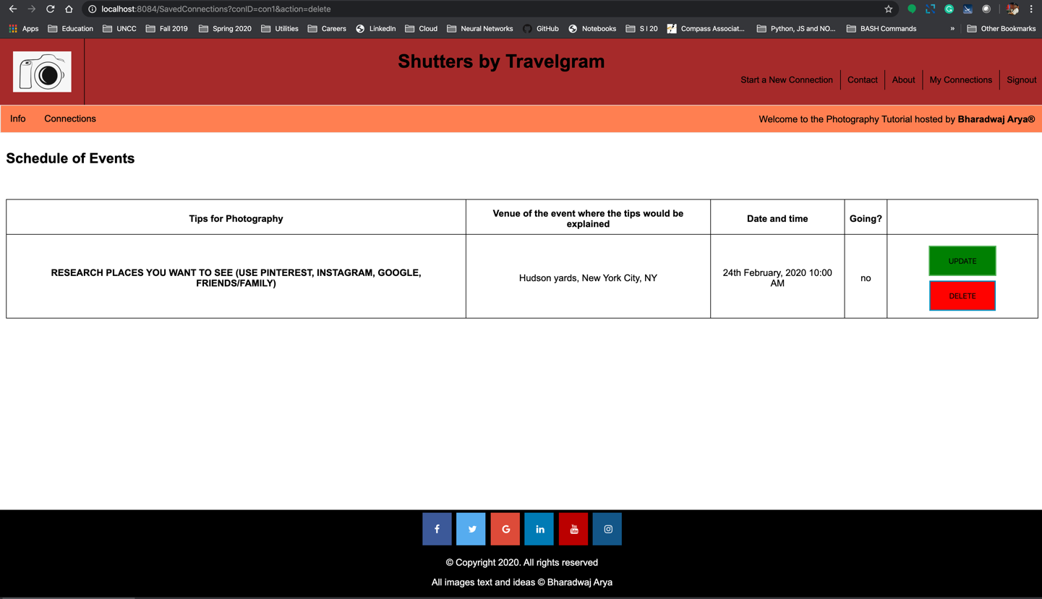

**When the user has clicked the Sign-out option, the session that stores all the user data is destroyed, and the webpage is redirected to the home page**

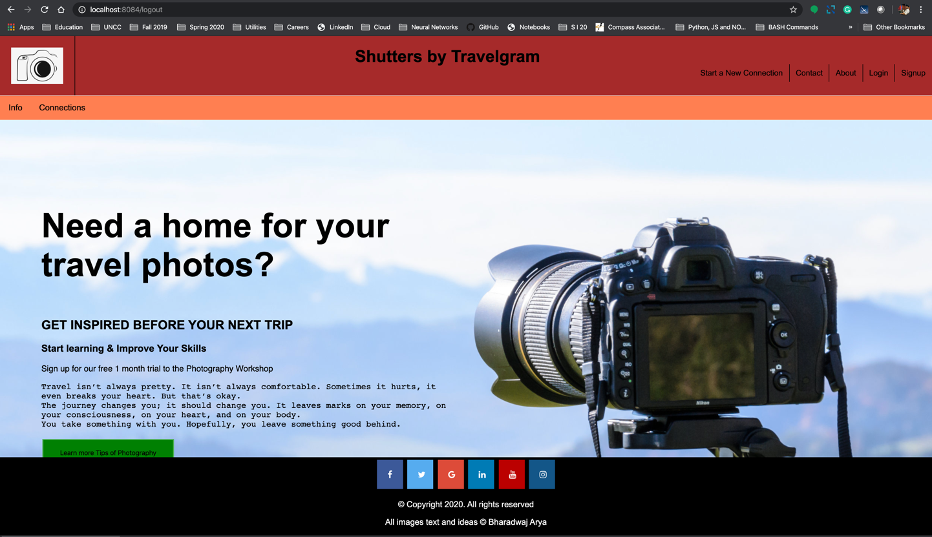

**Each of the places in the site where a user can take an action that uses the dynamic data from this milestone should be updated to make the appropriate GET or POST request with the necessary parameters or form.**

**Improvements and implementation of MongoDB in this Milestone:**

**Sample Design:**

* **getUserProfile(email/userID)** - this function returns a collection/list of all UserConnection objects saved
* **addRSVP(connectionID, userID, rsvp)** –  this function associates a connection to the user with userID (when the user saves the connection) and updates the RSVP that user provides for a connection with this connection ID. The corresponding database document can use the userID and connectionID as unique identifiers (keys).
  + Note: you need to be able to distinguish between connections that belong to the user (they shared it) vs. connections they RSVP to. If you have not done so already, add a user ID field to each connection in the database. This will allow you to tell which users own which connections.
* **updateRSVP(connectionID, userID, rsvp)** – this function updates the rsvp field for a user with userID for connection with connectionID.
* **addConnection(connection)** - this function handles the new connection form and adds a new connection to the list of connections in the database.



**List of all collections maintained in the db(milestone5)**

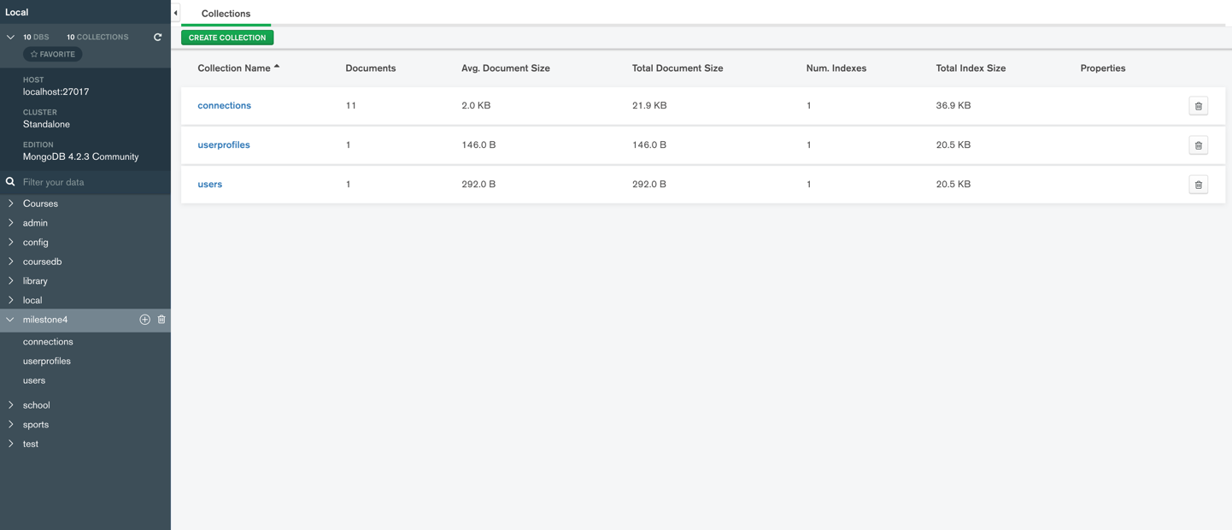

**Initially when the user tries to login, the user needs to login using a random username and password which is a mandatory field to retrieve the user details which is hardcoded in the userDB**

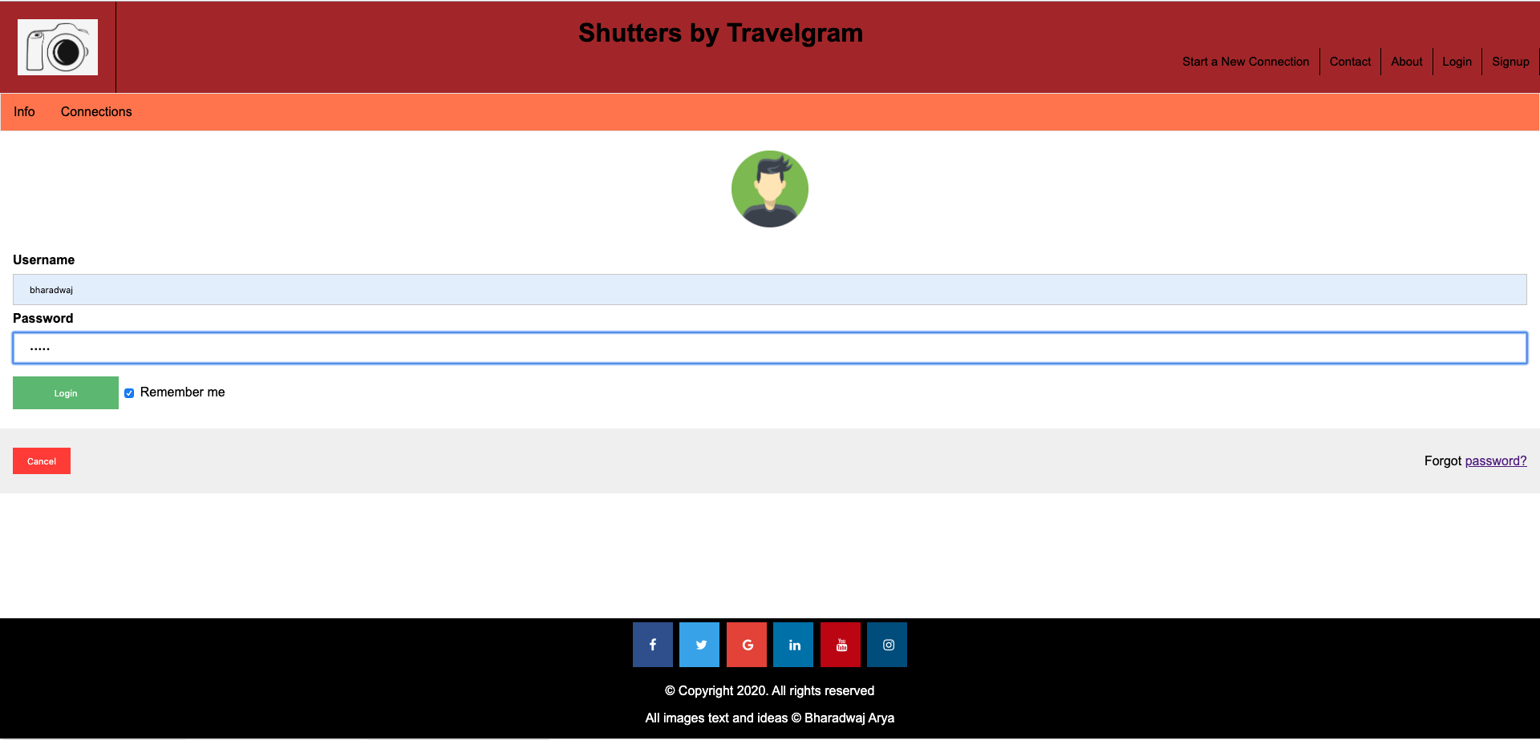

**The below is a list on connections which are maintained in the milestone4 db under the collections name connections. Hence when the user clicks on connections after he logged in the connections which are maintained will get displayed as shown below. As we can see the user’s first name and Last name has been displayed which is actually retrieved from the userDB.**

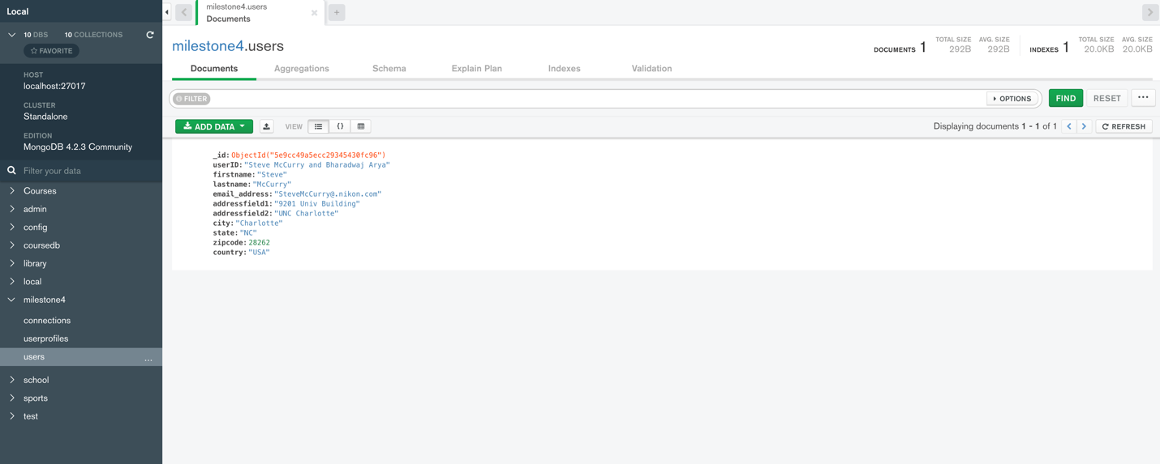

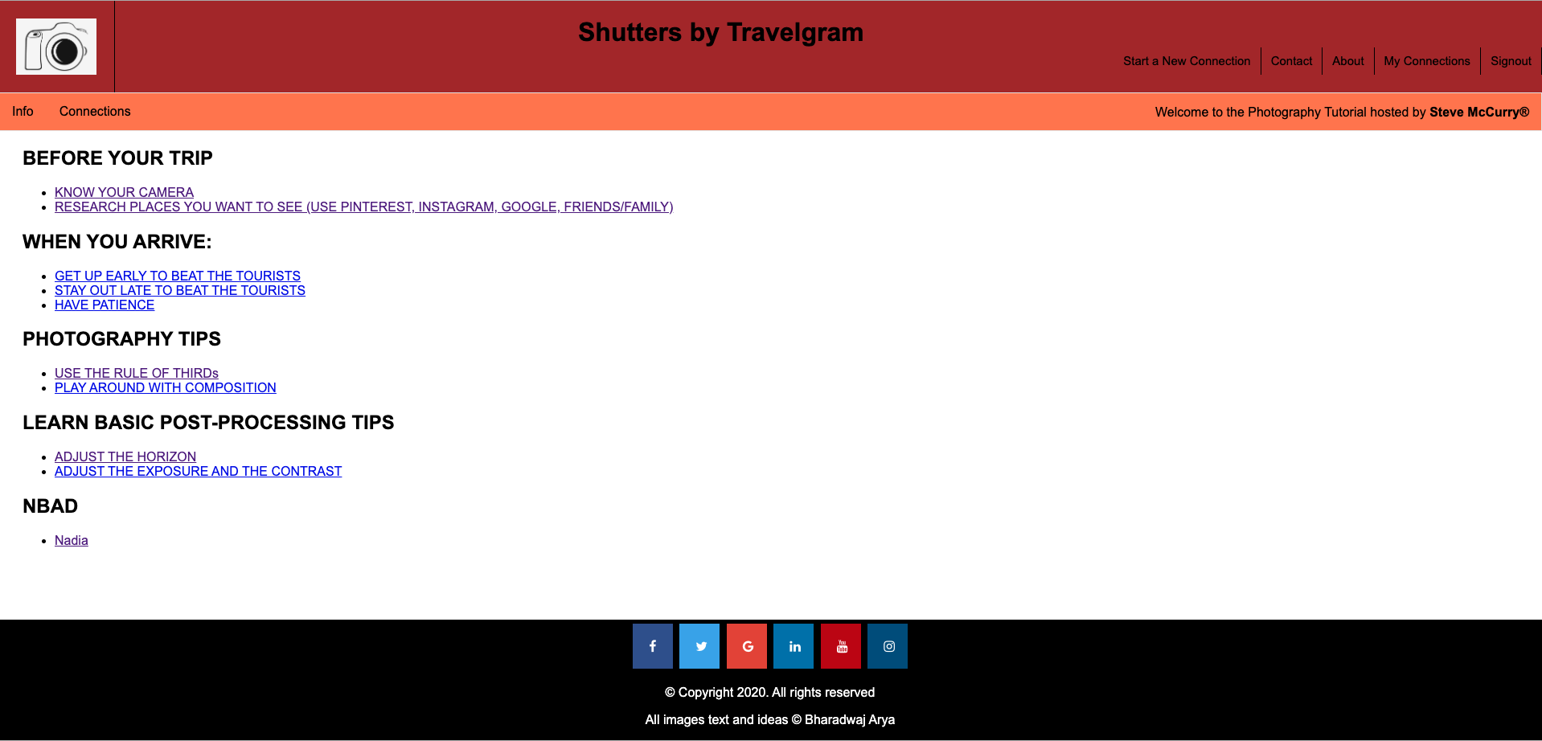

**Now when a user is clicking on a particular connection detail listed under a connection category and performs an RSVP action the action should be updated in the userProfile db too**

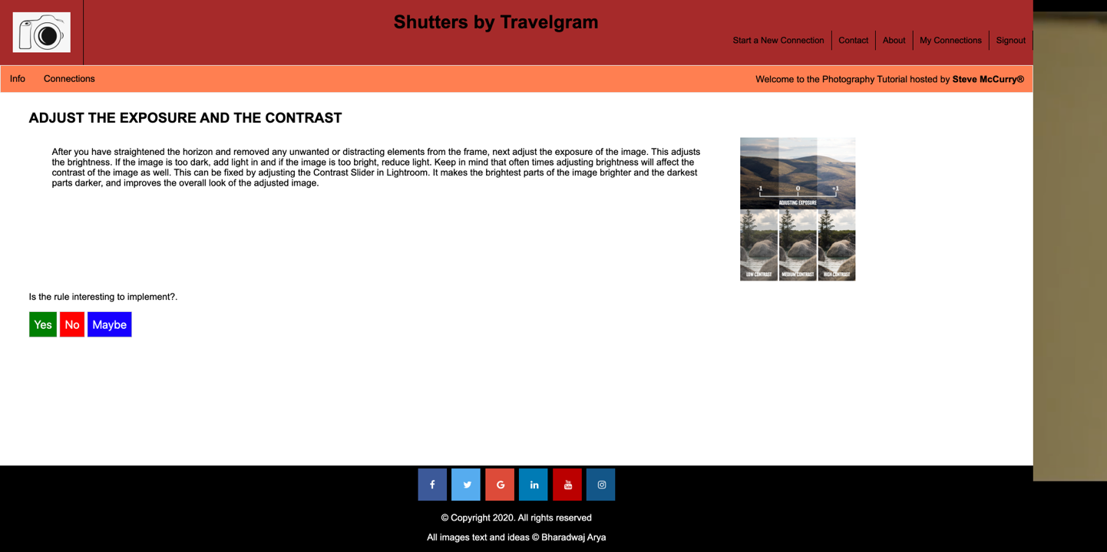

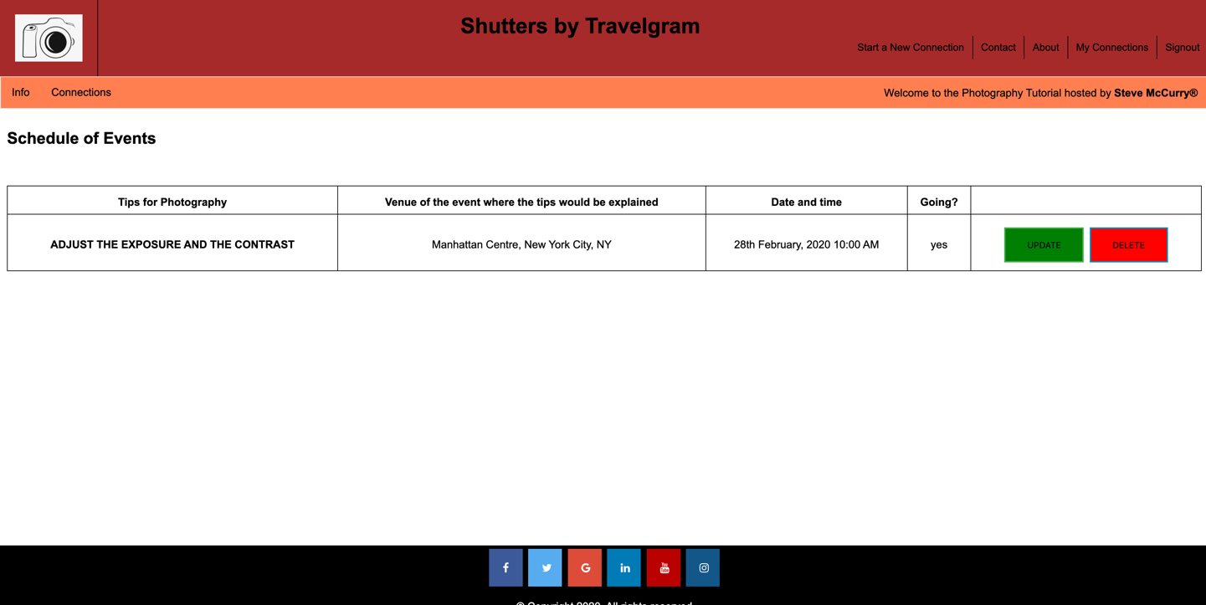

**The RSVP action of the logged in user is stored in the userprofilesDB. As we can see that the user has updated his interest as YES for attending the event, the same rsvp action is logged in the userprofiles DB. If the user wishes to update his choice of interest and would like to change the RSVP action to NO or Maybe, the same would be logged in the useprofile db too.**

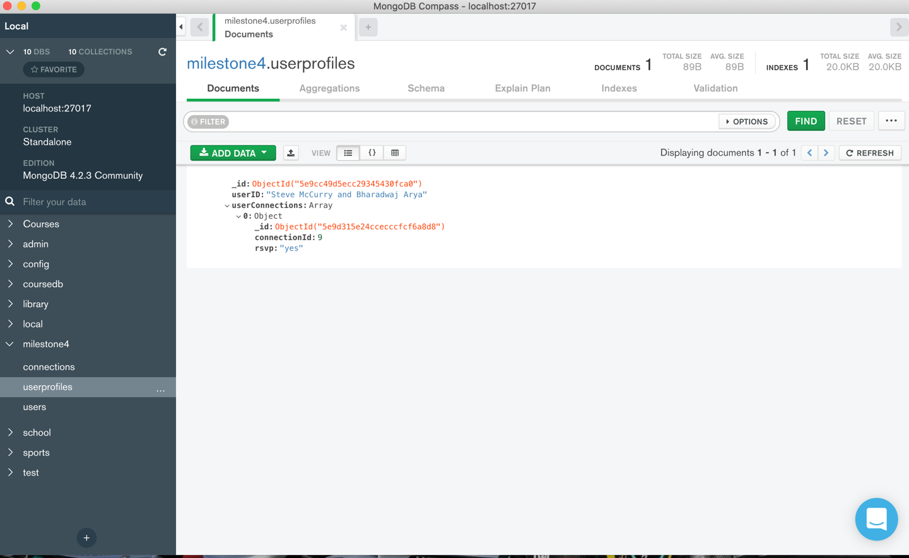

**List of all the connections which is maintained in the connections db**

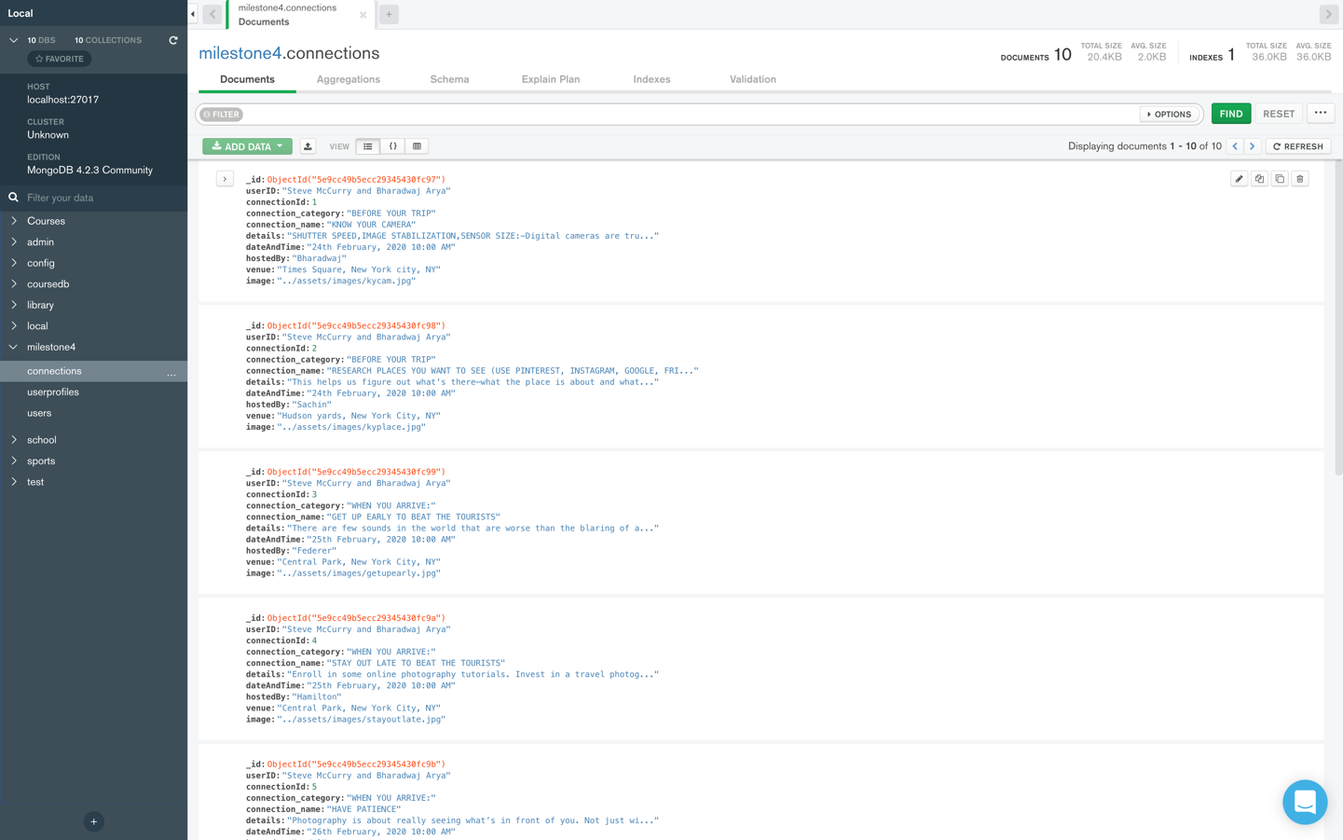

**We could see that the RSVP action of NO has been logged in the userprofiles DB**

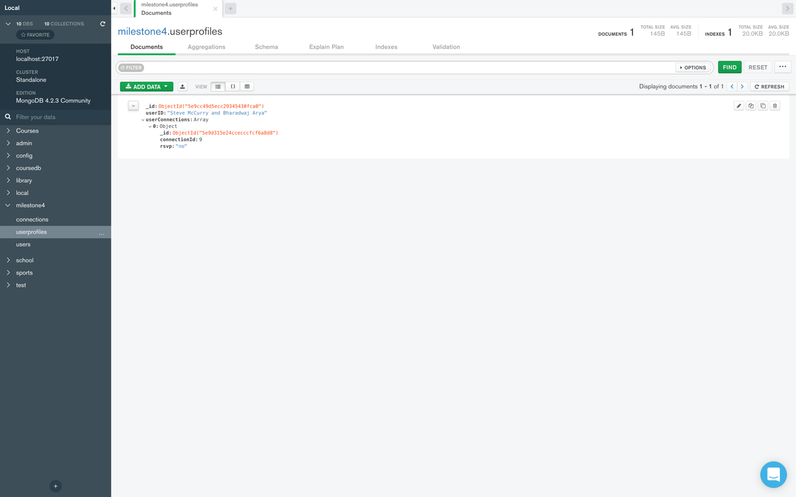

**If the user is trying to DELETE a particular connection the same gets deleted in the userprofiles DB too.**

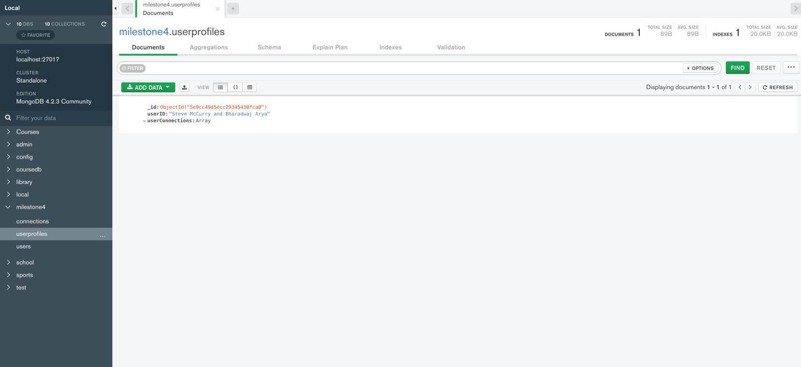

When a user wants to manually add a connection, he can do it so by **navigating to the Start a new connection present in the navigation bar.**

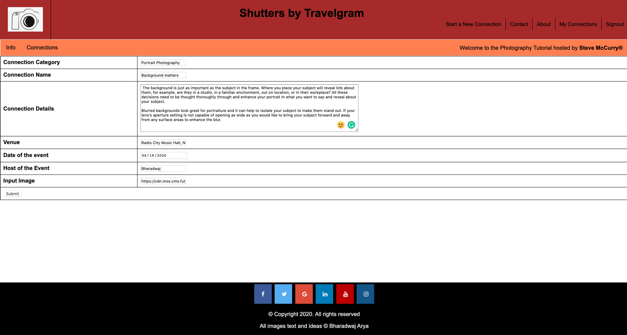

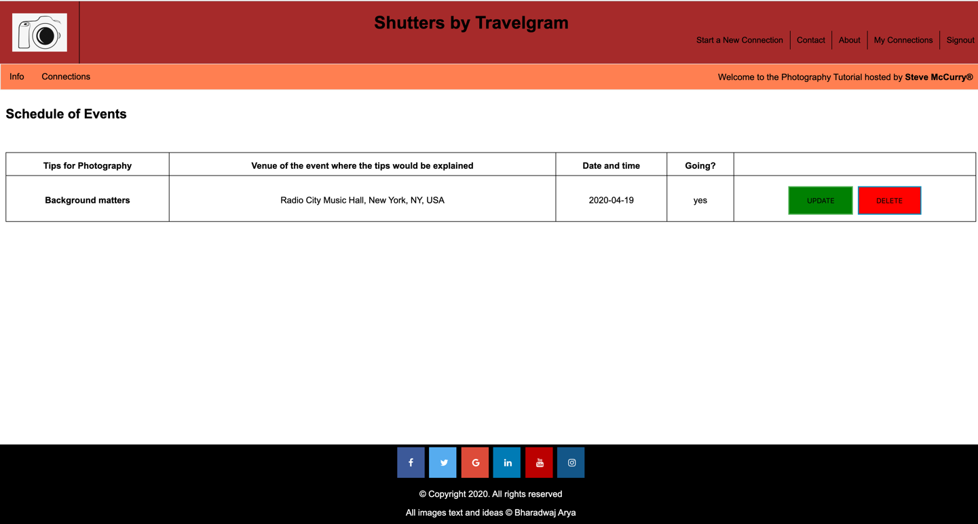

In order to check whether the connection had been created or not we can navigate to Connections to view it. **The same connection is also created in the db**

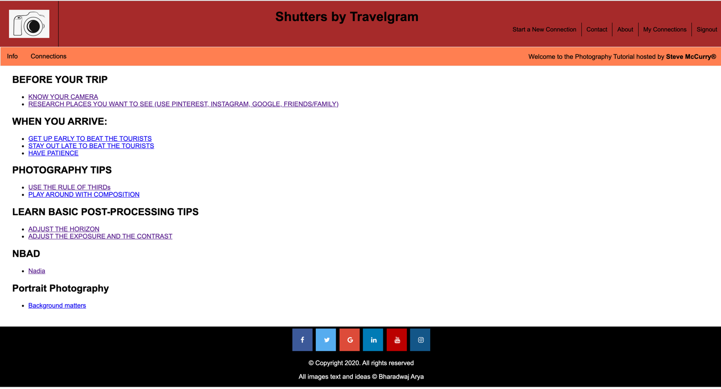

**As per the functionality a new connection has been created in the connections db**

**Below is the code for creating a database in MongodB by name Milestone 4 and inserting 3 collections by name:**

* **User**
* **UserProfile**
* **Connections.**

**use milestone4;**

**db.dropDatabase();**

**db.createCollection('connections');**

**db.createCollection('userprofiles');**

**db.createCollection('users');**

**db.users.insertOne(**

**{**

**userID:"Steve McCurry and Bharadwaj Arya",**

**firstname:"Steve",**

**lastname:"McCurry",**

**email_address:"SteveMcCurry@.nikon.com",**

**addressfield1:"9201 Univ Building",**

**addressfield2:"UNC Charlotte",**

**city:"Charlotte",**

**state:"NC",**

**zipcode:28262,**

**country:"USA"**

**}**

**);**

**db.connections.insertMany([**

**{userID:"Steve McCurry and Bharadwaj Arya",connectionId:01 , connection_category:'BEFORE YOUR TRIP' ,connection_name:'KNOW YOUR CAMERA',details:'SHUTTER SPEED,IMAGE STABILIZATION,SENSOR SIZE:-Digital cameras are truly astonishing tools! It is remarkable, the photographic challenges they digitally solve in an instant to capture beautiful images. To use your camera to its full capability youΓÇÖve got to be familiar with its functions. Unfortunately, this means youΓÇÖll have to read (then re-read- repeat many times) the manual! These articles are intended to replace the technical aspects of a userΓÇÖs manual. Each article contains at least one sentence as to when to use that particular function.,', dateAndTime:'24th February, 2020 10:00 AM', hostedBy:'Bharadwaj',venue:'Times Square, New York city, NY',image:'../assets/images/kycam.jpg'},**

**{userID:"Steve McCurry and Bharadwaj Arya",connectionId:02 , connection_category:'BEFORE YOUR TRIP' ,connection_name:'RESEARCH PLACES YOU WANT TO SEE (USE PINTEREST, INSTAGRAM, GOOGLE, FRIENDS/FAMILY)',details:'This helps us figure out what\'s thereΓÇöwhat the place is about and what subjects we need to cover. Read brochures and travel books. Go to libraries, bookstores, or onto the Web. Talk to friends who have been there. Pick up travel information at the country\'s embassy. Find whatever you can that is relevant, and devour it. Understanding the customs and traditions of a place is vital. For one thing, you want to be sure you act in a way that is not rude or offensive while you are there, and it\'s hard to know what\'s acceptable and what isn\'t with some knowledge. It can also help you understand things people do that at first encounter you might consider incomprehensible or even horrifying.' ,dateAndTime:'24th February, 2020 10:00 AM',hostedBy:'Sachin',venue: 'Hudson yards, New York City, NY',image:'../assets/images/kyplace.jpg'},**

**{userID:"Steve McCurry and Bharadwaj Arya",connectionId:03 , connection_category:'WHEN YOU ARRIVE:' ,connection_name:'GET UP EARLY TO BEAT THE TOURISTS',details:'There are few sounds in the world that are worse than the blaring of an alarm clock. Beep, beep, beep. It so rarely signifies anything good, or enjoyable. Mostly it just means it\'s time to go to work.\'' ,dateAndTime:'25th February, 2020 10:00 AM',hostedBy:'Federer',venue: 'Central Park, New York City, NY',image:'../assets/images/getupearly.jpg'},**

**{userID:"Steve McCurry and Bharadwaj Arya",connectionId:04 , connection_category:'WHEN YOU ARRIVE:' ,connection_name:'STAY OUT LATE TO BEAT THE TOURISTS',details:'Enroll in some online photography tutorials. Invest in a travel photography workshop. Go out and practice on a regular basis' ,dateAndTime:'25th February, 2020 10:00 AM',hostedBy:'Hamilton', venue:'Central Park, New York City,**

**NY',image:'../assets/images/stayoutlate.jpg'},**

**{userID:"Steve McCurry and Bharadwaj Arya",connectionId:05 , connection_category:'WHEN YOU ARRIVE:' ,connection_name:'HAVE PATIENCE',details:'Photography is about really seeing whatΓÇÖs in front of you. Not just with your eyes, but with your heart & mind too. This requires dedicated time and attention. Slow down and make a conscious effort at becoming aware of your surroundings before pressing the shutter.Pay attention to details.' ,dateAndTime:'26th February, 2020 10:00 AM',hostedBy:'Nadal',venue:'Brooklyn Bridge, New York City, NY',image:'../assets/images/havepatience.jpg'},**

**{userID:"Steve McCurry and Bharadwaj Arya",connectionId:06 , connection_category:'PHOTOGRAPHY TIPS' ,connection_name:'USE THE RULE OF THIRDs',details:'This well-known photography rule still holds true. When in doubt, make sure you\'re using the rule of thirds to set up your photo.When framing a photo, imagine the scene divided up as above. Think about what elements of the photo are most important, and try to position them at or near the lines and intersections of the grid. They don\'t have to be perfectly lined up as long as they\'re close.For landscpaes: place it along one of the horizontal line.For Vertical Subjects: split a photo in two, in much the same way as a horizon can do horizontally. To avoid this, position them off-centre in your composition</li>',dateAndTime:'26th February, 2020 10:00 AM',hostedBy:'Vettel',venue:'Brooklyn Bridge, New York City, NY',image:'../assets/images/twothirdrule.jpg'},**

**{userID:"Steve McCurry and Bharadwaj Arya",connectionId:07 , connection_category:'PHOTOGRAPHY TIPS' ,connection_name:'PLAY AROUND WITH COMPOSITION',details:'Composition, at its most basic, is how you place your subject (and everything else) in your image.' ,dateAndTime:'26th February, 2020 10:00 AM',hostedBy:'Djokovic',venue:'Hudson yards, New York City, NY',image:'../assets/images/composition.jpg'},**

**{userID:"Steve McCurry and Bharadwaj Arya",connectionId:08, connection_category:'LEARN BASIC POST-PROCESSING TIPS',connection_name:'ADJUST THE HORIZON',details:'It is easier to fix the horizon because we can make sure the horizon is straight before we take the image with our camera. Some tripod comes with an inbuilt fluid level that you can use to make sure the horizon is straight. You can also get a fluid level mount to the hot shoe of your camera. These are relatively cheap on the internet. It is a bit more challenging to control for perspective. For example, when photographing architecture, unless you are high up above the ground, the building is going to be tilted. This is because we often shoot from the ground with our camera tilted upwards to include the whole building into the frame. For those who are serious about architectural photography, you consider getting a tilt-shift lens for that purpose.',dateAndTime:'28th February, 2020 10:00 AM',hostedBy:'Murray',venue:'Manhattan Centre, New York City, NY',image:'../assets/images/adjusthorizon.jpg'},**

**{userID:"Steve McCurry and Bharadwaj Arya",connectionId:09, connection_category:'LEARN BASIC POST-PROCESSING TIPS',connection_name:'ADJUST THE EXPOSURE AND THE CONTRAST',details:'After you have straightened the horizon and removed any unwanted or distracting elements from the frame, next adjust the exposure of the image. This adjusts the brightness. If the image is too dark, add light in and if the image is too bright, reduce light. Keep in mind that often times adjusting brightness will affect the contrast of the image as well. This can be fixed by adjusting the Contrast Slider in Lightroom. It makes the brightest parts of the image brighter and the darkest parts darker, and improves the overall look of the adjusted image.',dateAndTime:'28th February, 2020 10:00 AM',hostedBy:'Murray',venue:'Manhattan Centre, New York City, NY',image:'../assets/images/expcontrast.jpg'}**

**]);**

**db.userprofiles.insertOne(**

**{**

**userID:"Steve McCurry and Bharadwaj Arya",**

**userConnections:[**

**{**

**connectionId:02,**

**rsvp:'yes'**

**},**

**{**

**connectionId:05,**

**rsvp:'no'**

**}**

**]**

**}**

**);**

**Changes implemented in Milestone 5**

**Security checks at login Page**

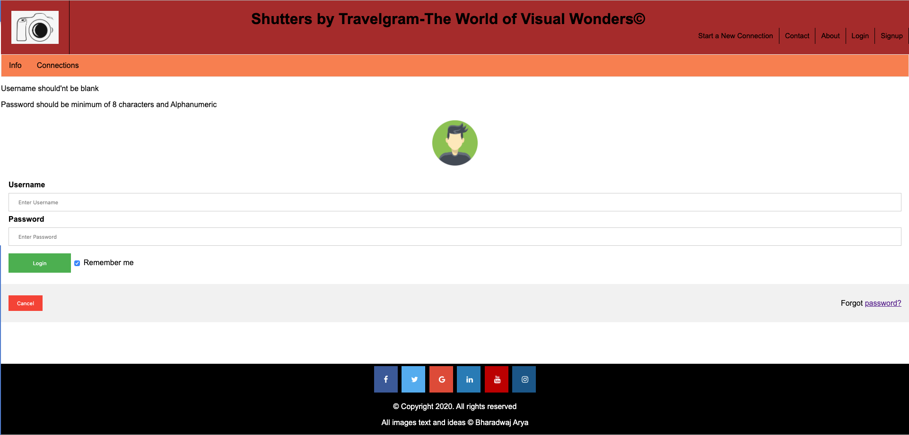

**Password validation check**

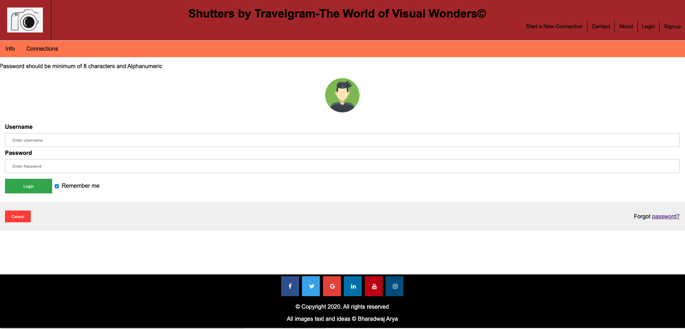

**Validation check for input fields in Signup Page**

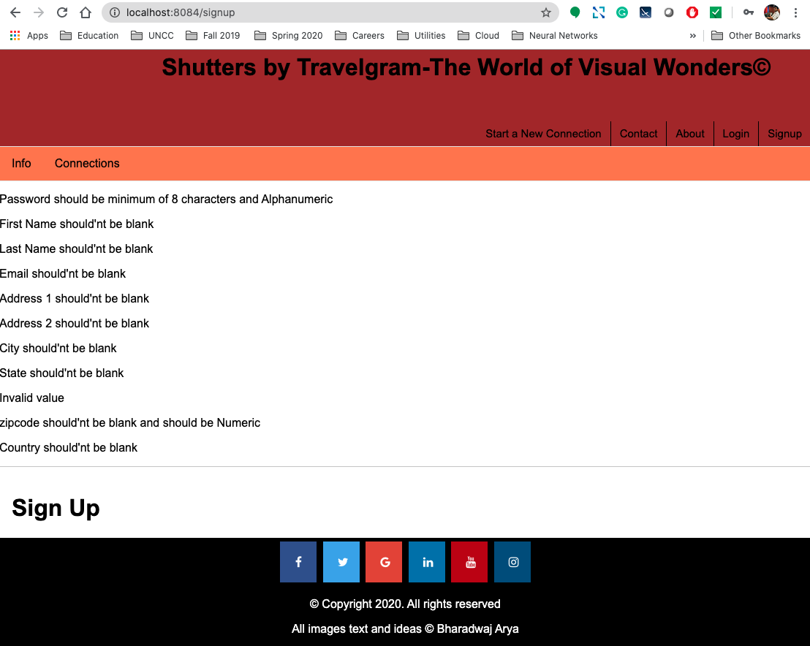

**User ID, Password and Email validation in Signup Page. These should be mandatory fields that should be given by the user while he/she is signup to the website**

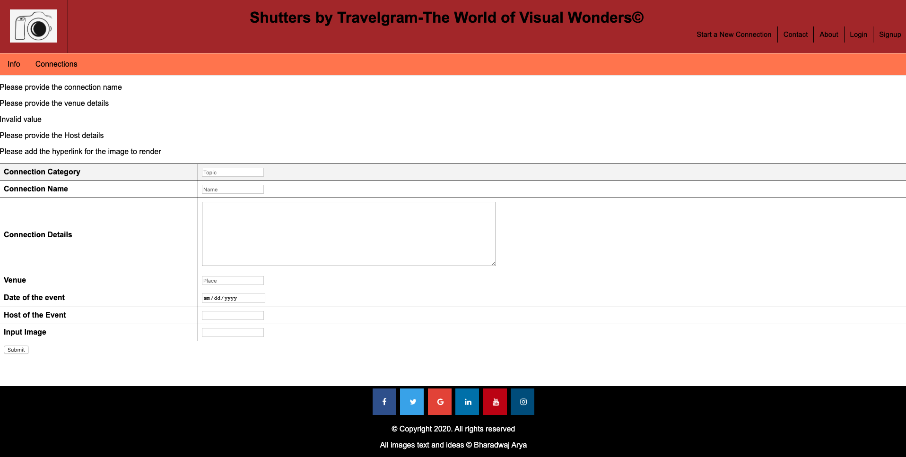

**Input validation checks while the use is trying to add new connection**

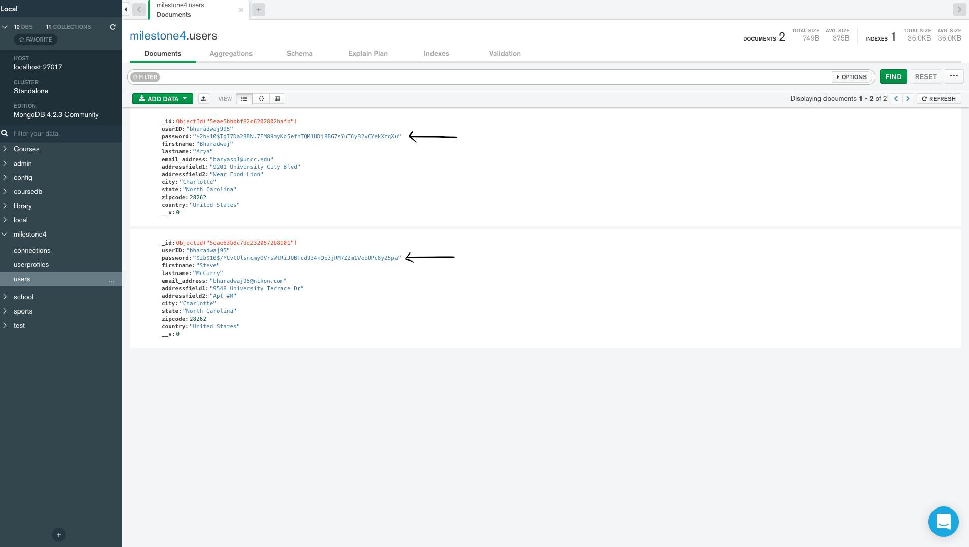

**Salting and Hashing of passwords inputted by the user while signup and validating the hashed password in dB with the password given by the user and un hash the same**